Fully Optimized Calendar Event
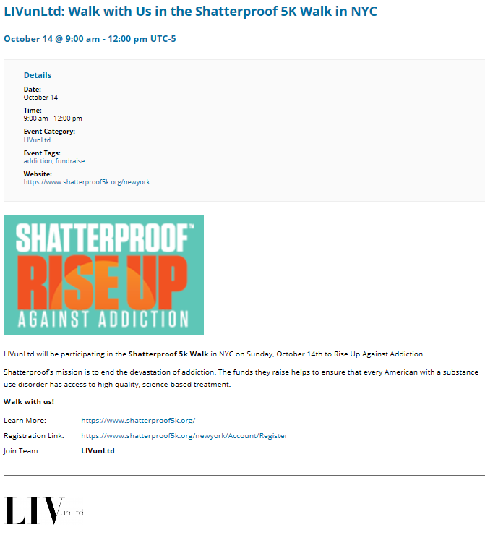
1

2

3

4
5

6

7

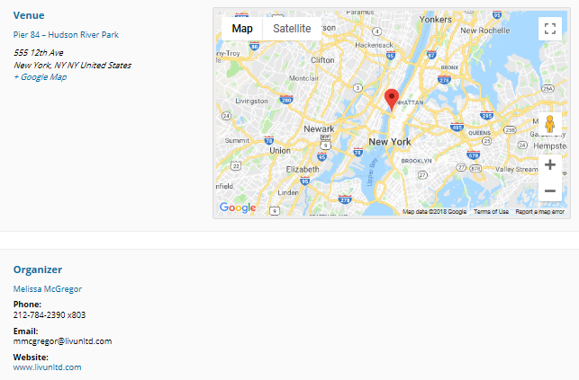
9
8
10

Calendar Event Components
Event: http://purpose.firstservice.com/event/livunltd-shatterproof-5k-walk/
1. Event Title: “Company Name: Call to Action”
2. Event Details:
- Date & time of the event
- The name of the company that is organizing the event

3. Event Tags: Include tags that are most relevant to the event
- Examples of tags to use are:

Type of Event | Event Cause
#participate  #volunteer  #donate  #fundraise | #nopoverty #qualityeducation  #zerohunger #genderequality  #reduceinequality #children  #goodhealth #veterans  #mentalhealth #environment  #cancer #water  #addiction #animalwelfare

4. Website: Include the link to the event website
- Note: If there is no event website, include the charity/organization’s website

5. Image: Include an image that is related to the event

6. Event Description: Provide a brief description of the event, outlining the purpose (cause) and how people can get involved
- Note: Use bold text to highlight important information and a list format to communicate ‘next steps’ more clearly

7. Company Logo: Include the company logo with a hyperlink to the company’s official website

8. Venue Details: Enter the event location
- Note: If you are collecting donation items at your office, use your office location as the venue

9. Google Maps:
- Include the Google maps image and Google maps link to the event location

10. Event Organizer:
- Event organizer must be a company employee – not a representative from the non-profit the event is supporting
- The organizer is the person people would contact with questions regarding the event
- Include the event organizer’s name and contact information (phone number and/or email)

