9-11 Memorial Stair Climbs: Remembering fallen firefighters
September 11, 2001 marks the deadliest terror attack in human history, when 19 men hijacked four U.S. commercial airplanes claiming the lives of 2,977 people. Of those who perished, 343 were Fire Department of New York (“FDNY”) firefighters.
Each year throughout the U.S., FDNY firefighters who selflessly gave their lives that fateful day so that others could live are remembered and honored through a series of memorial stair climb events. These events support the National Fallen Firefighters Foundation (“NFFF”), and its mission to remember and honor America’s fallen fire heroes and to provide resources to help their survivors rebuild their lives. The NFFF also works within the fire service community to reduce firefighter deaths and injuries.
Memorial stair climb events are held in a variety of different venues ranging from sports stadiums to government buildings to luxury high-rise condos. At each venue, participants pay tribute to a fallen FDNY firefighter by climbing the equivalent of the 110 stories of the World Trade Center. Each individual tribute remembers the sacrifice of a firefighter and symbolically completes their heroic journey. Participants are given name badges bearing the name of a fallen firefighter and complete the climb in his or her memory.
Many within the FirstService family participated in stair climb events this year.
In upstate New York, Scott Colbert, a Paul Davis Restoration franchise owner, gathered a team to participate in the Binghamton Memorial Stair Climb on September 16. His reasons for participating were very personal. As a Marine Corp veteran, he knows first hand the sacrifices men and women make for their country every day and has a deep level of respect for first responders. “It is important to me that first responders know we are behind them,” said Colbert.
Scott and his team are already thinking about how they can have an even bigger impact next year. “Binghamton is a few hours from our offices so next year we are planning to rent a bus to transport local volunteer firefighters to participate along with us. This is a small way we can thank them for their service and honor their fallen brethren.”
In Atlanta, Pascale Elkhouri-Kowalski, executive assistant at FirstService Residential, helped organize the Atlanta office’s third memorial stair climb which raised $20,000 for the NFFF. Each year the Atlanta team partners with a client property to host the event on-site. The Sovereign, a 50-story high-rise in Buckhead, was chosen as the site for this year’s climb. More than 200 climbers made two trips up and down and finished off the climb with a final 10-story ascent.
Although the locations vary, each stair climb follows a similar format. Following the playing of the national anthem, a fire department chaplain leads the group in a prayer and moment of silence for the fallen. Then participants follow a bag piper in a somber procession into the building to begin the climb. Upon completion of the climb, each participant rings a bell in honor of the fallen firefighter in whose memory they climbed.
“This event always triggers a wide range of emotions for me. Seeing the firefighters in their full gear climb the stairs is a very poignant reminder of the sacrifices made that day,” said Elkhouri-Kowalski. “My favorite part of the event is seeing people of all ages from all walks of life come together to honor and remember the fallen.”
If you are interested in hosting a stair climb event in your area, please visit https://www.firehero.org/events/9-11-stair-climbs/host-climb/ for detailed information on how to get started.

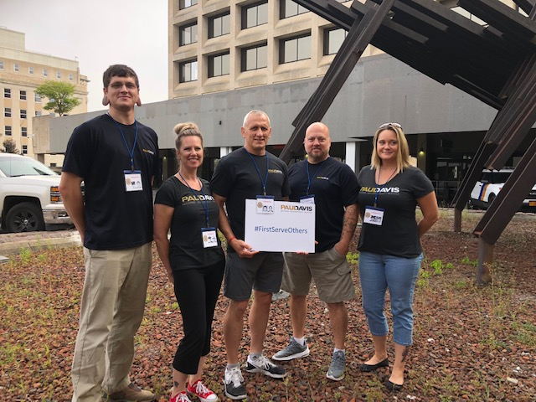
From left, Adam Colbert, Project Manager, Kim Colbert, JCA, Scott Colbert, GM, Chris Watkins, Mitigation Manager, Amanda Kendrick, Business Development Manager
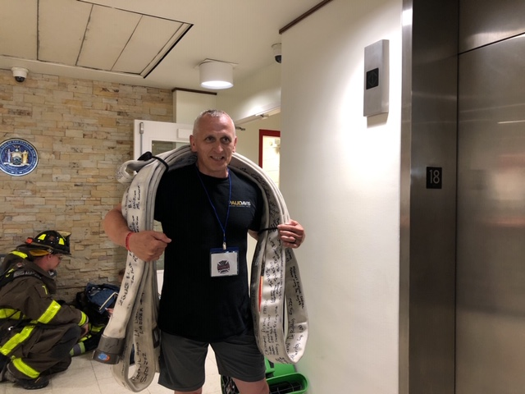
Scott Colbert pictured carrying a fire hose. On average, a 50’ length of hose weighs 52 lbs.
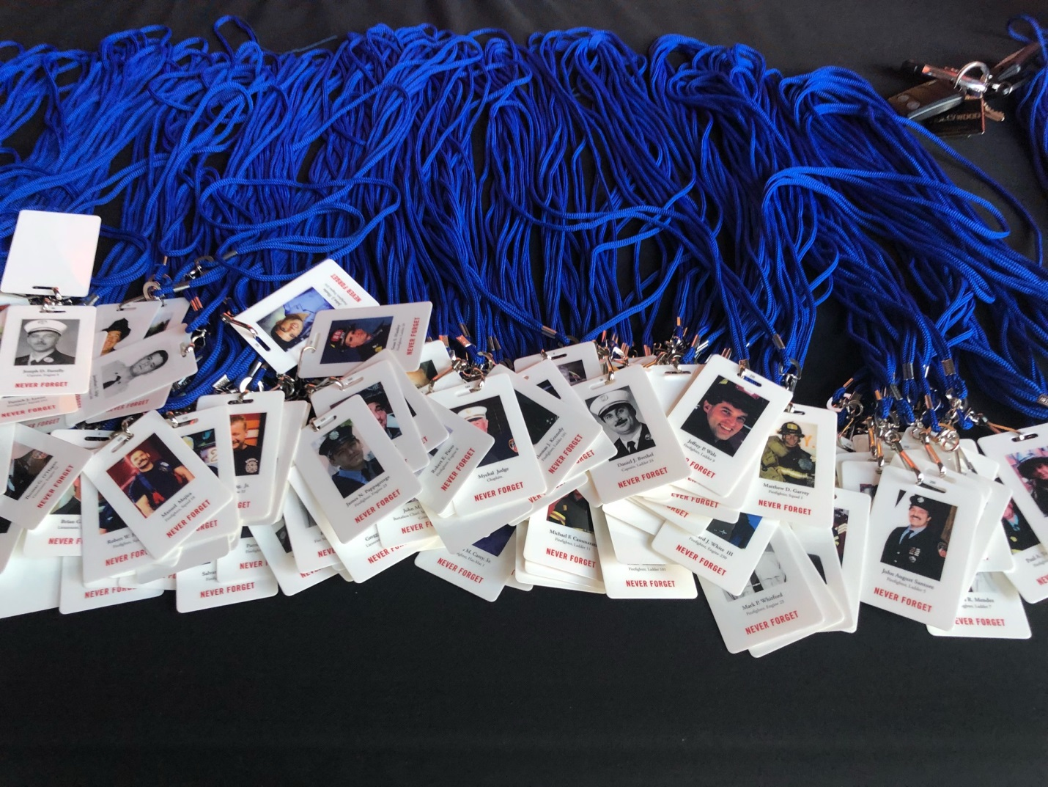
At each stair climb, participants are given name badges of fallen fire heroes.
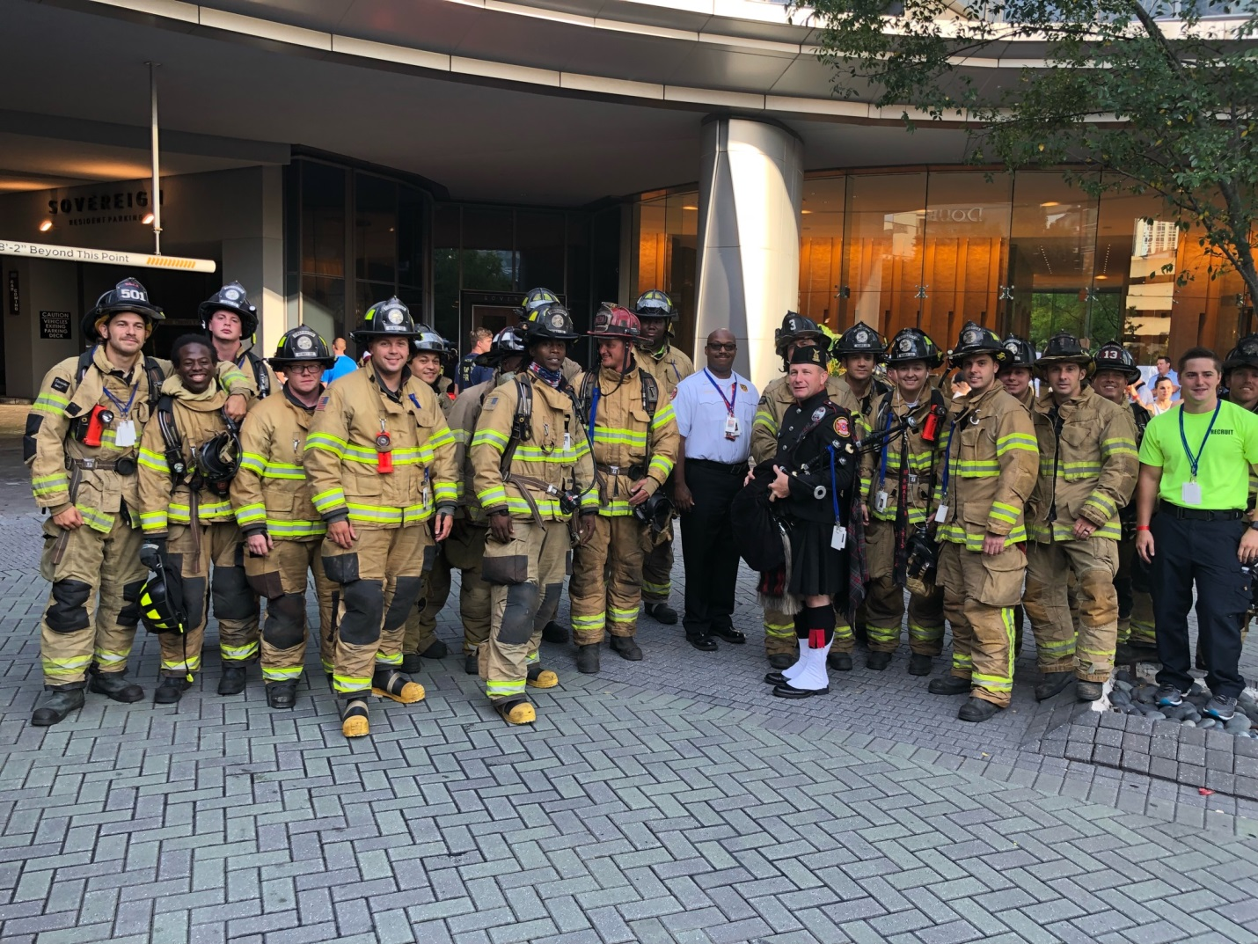
Members of the Atlanta Fire Rescue Department assemble before the climb
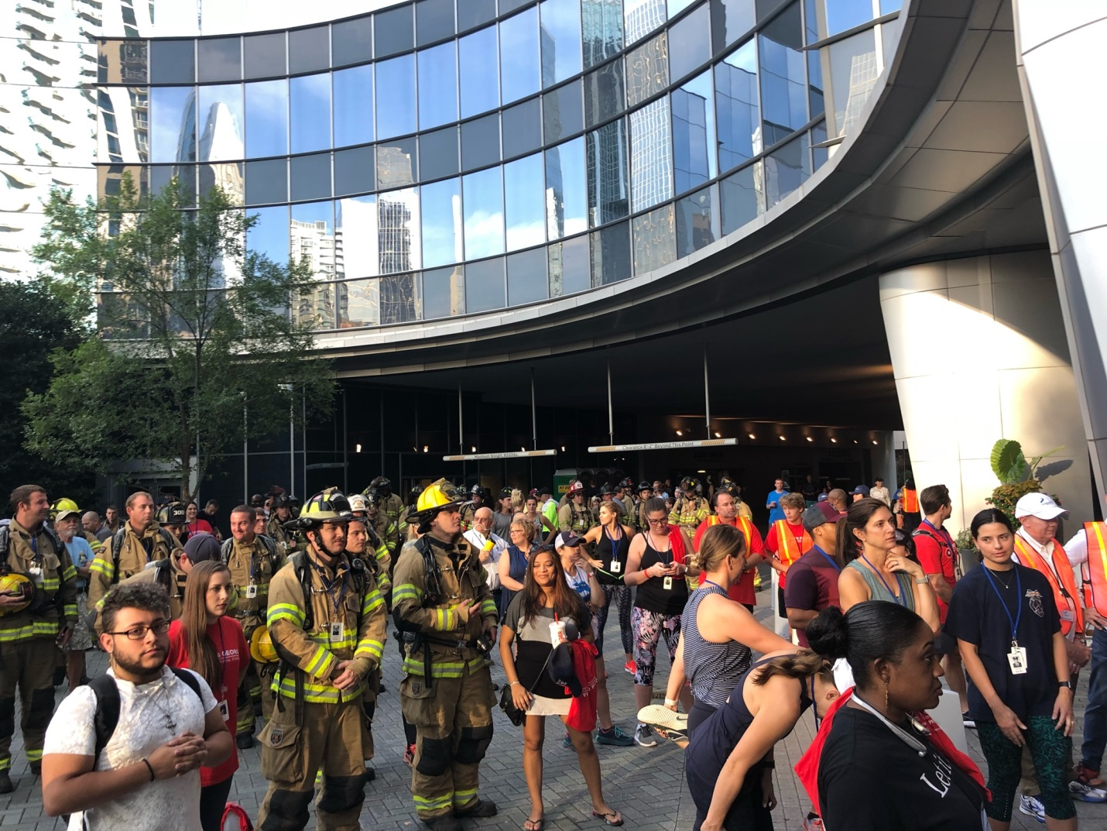
More than 200 participants joined together at the FirstService Residential stair climb event at The Sovereign in Atlanta to honor and remember fallen firefighters

